**ASSIGNMENTS**

1. **What is SDLC?**

SDLC (Software Development Life Cycle) is a structure imposed on a development of a software which defines process for planning, design, implementation, documentation, deployment, testing, ongoing maintenance, and support.

1. **What is Software Testing?**

It is a process to identify (Verification & Validation) correctness, completeness and quality of developed software.

1. **What is agile methodology?**

Agile model is combination of iterative and incremental process models with focus on process adaptability and customer satisfaction by rapid delivery of working software product.

1. **What is SRS?**

SRS (software requirement specification) is a complete description which defines a behaviour of a system to be developed, it also includes non-functional requirements of the system.

1. **What is oops?**

It is Object oriented set of instructions to accomplish specific task.

1. **Write Basic Concepts of oops**

* Object
* Class
* Encapsulation
* Inheritance
* Polymorphism
* Abstraction

1. **What is object?**

It is example/instance/representative of a class. It is part of a class.

1. **What is class?**

It is a group of objects. Class can have many objects but object may relate to a single class only.

1. **What is encapsulation?**

It is a wrapping up of data into a single unit.

1. **What is inheritance?**

It is ability to adapt the behaviour of a parent class into child class.

1. **What is polymorphism?**

It allows different objects to respond to the same message in different ways, the response specific to the type of the object.

1. **Draw Usecase on Online book shopping**

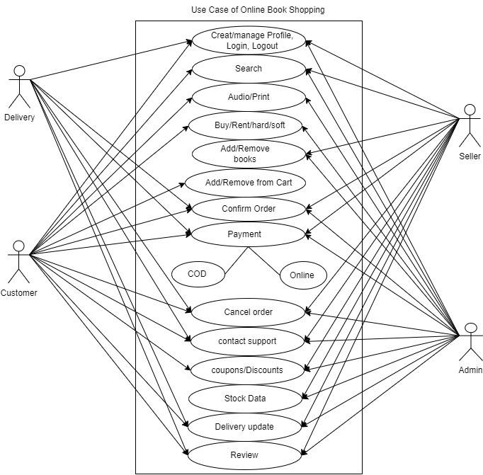

1. **Draw Usecase on online bill payment system (paytm)**

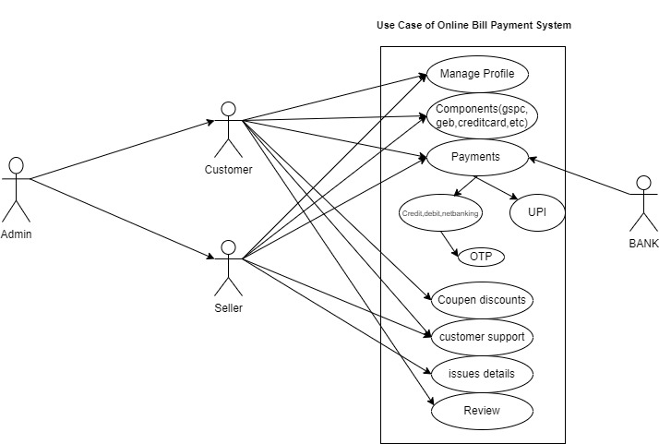

1. **Write SDLC phases with basic introduction**
2. Requirements Gathering – It is a process to obtain complete customer requirements.
3. Data Analysis – It is a phase which defines what customer is trying to solve.
4. Design – It defines technical specification of software product.
5. Implementation - It is a phase where actual software development happens .
6. Testing – Validate the software product developed at the end of implementation phase.
7. Maintanance – Repair & make changes as per new requirements.
8. **Explain Phases of the waterfall model**
9. Requirment Gathering – Document of detailed project requirements.
10. Data Analysis - It is a phase which defines what customer is trying to solve and WHAT we are planning to develop.
11. Design – In this phase, specification of software product is designed/decided.
12. Implementation – It is a phase where actual software development is taking place.
13. Testing – Here correctness, completeness and quality of software is verified.
14. Maintenance – repair of software product to adapt software to the new environment.

Waterfall Method is unidirectional.

Customer input is at the beginning of the project and after the development of the product.

1. **Write phases of spiral model**
2. Planning - Determination of objective, alternative, restrains, initial requirements.
3. Risk Analysis – Analysis of alternative/identification of risk. It is a go or no-go phase.
4. Engineering – Development and testing of the product. Proto type is developed and tested here.
5. Customer evaluation – Software demo is provided to customer for validation purpose.

At the end of customer evaluation, new requirements of customer are accommodated by following all phases in sequential manner and updated product is provided to customer at the end of last phase.

This repetition continue until customer requirements are met and no new requirements are provided by user.

1. **Write agile manifesto principles.**
2. Working software, over comprehensive documentation
3. Individuals and interactions, Over processes and tools
4. Customer collaboration, Over contract negotiation
5. Responding to change, over following a plan
6. **Explain working methodology of agile model and also write pros and cons.**

* Agile SDLC model is a combination of iterative and incremental

process models with focus on process adaptability and customer

satisfaction by rapid delivery of working software product.

* Agile Methods break the product into small incremental builds.

These builds are provided in iterations. Each iteration typically lasts from about one to three weeks.

* Every iteration involves cross functional teams working

simultaneously on various areas like planning, requirements analysis,

design, coding, unit testing, and acceptance testing.

* At the end of the iteration a working product is displayed to the customer and important stakeholders.
* PROS
* It Is a very realistic approach to software development.
* It promotes teamwork and cross training.
* Functionality can be developed rapidly and demonstrated.
* Resource requirements are minimum.
* Suitable for fixed or changing requirements
* Delivers early partial working solutions.
* Good model for environments that change steadily.
* Minimal rules, documentation easily employed.
* Little or no planning required & easy to manage.
* Cons
* Not suitable for handling complex dependencies.
* More risk of sustainability, maintainability and extensibility.
* Strict delivery management dictates the scope, functionality to be delivered, and adjustments to meet the deadlines.
* Depends heavily on customer interaction, so if customer is not clear, team can be driven in the wrong direction.
* There is very high individual dependency, since there is minimum documentation generated.
* Transfer of technology to new team members may be quite challenging due to lack of documentation.

1. **Draw usecase on Online shopping product using COD.**

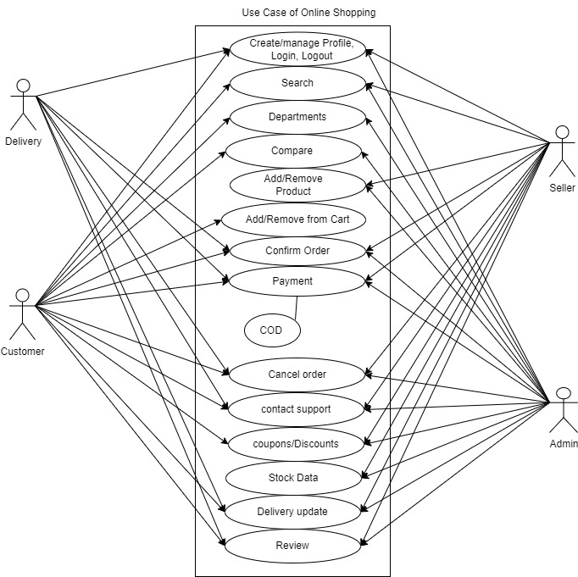

1. **Draw usecase on Online shopping product using payment gateway.**

